YOU’RE INVITED

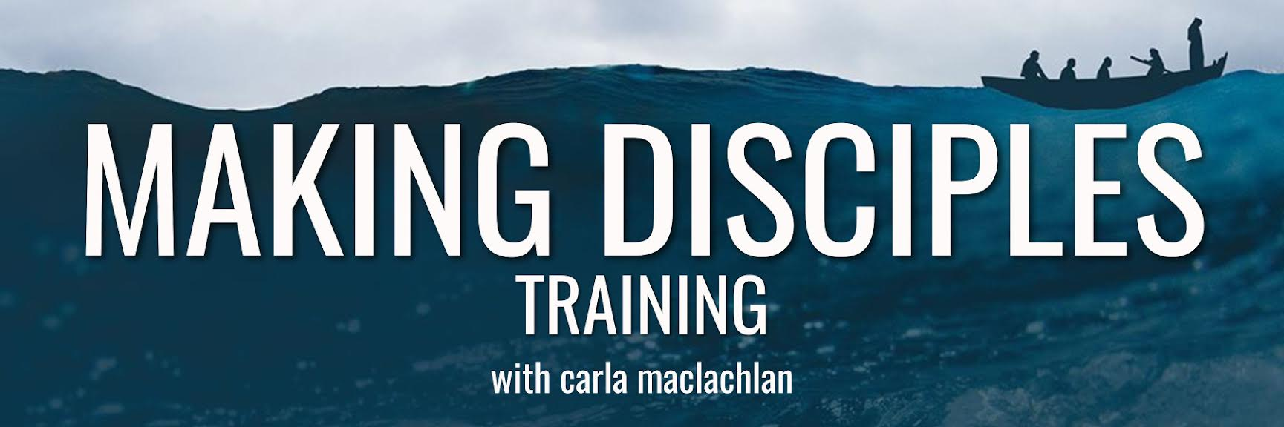

Please prayerfully consider attending Making Disciples training, with Carla MacLachlan, starting (fill in the date / place / time). This 12-week study equips followers of Christ to make disciples as God desires. (Briefly add what the training did for you.)

The training is free and includes weekly outlines and practical application. Let me know if you would like for me to reserve you a spot (include your contact information here). You are also welcome to invite a friend.

I look forward to growing in the Lord together and influencing others for Christ along the way.

See what people are saying about Carla’s training:
“Making Disciples has changed the trajectory of my faith. This class taught me how to authentically share my faith and how to glorify God in everything I do. Sign up for the class, do the homework, and get prepared for God to transform you as His disciple.” -- A. McCormick, Springfield MO

“As a result of taking this course, I’ve found a great new interest and commitment in applying Scripture pointedly. I strongly recommend this course.” – J. Rousseaux-Ramsey, Moab UT

“This class has opened my eyes and heart toward those I come in contact with every day. I’ve learned things I can say and do to begin a non-confrontational conversation with them about Jesus. But more importantly, who I am as a disciple of Jesus.” – J. Holdridge, Christian Blogger

“God is using Making Disciples to transform my life! When I began to embrace discipleship and disciple-making, my walk with Christ deepened. I better understand now that God is working in the moments of my days to bring Himself glory.” – B. Williams, Jacksonville FL

